Inquiry-Oriented Curricula:
Abstract Algebra, Linear Algebra, and Differential Equations
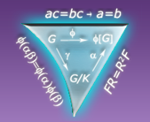
Inquiry-Oriented Abstract Algebra (IOAA)

- Topics include: groups, subgroups, isomorphisms, quotient groups, homomorphisms
- Intended to be used for a junior/senior introductory abstract algebra course
- Materials currently available: Student materials (task statements) and instructor support materials (learning goals, examples of student work, implementation notes). For more information (and materials), visit: http://www.web.pdx.edu/~slarsen/TAAFU/ (User:teacher; Password:TAAFU)
- History: Developed under NSF grant number 0737299 (PI: Larsen). Key personnel: Johnson.
- Evidence of efficacy: Larsen, Johnson, & Bartlo, 2013

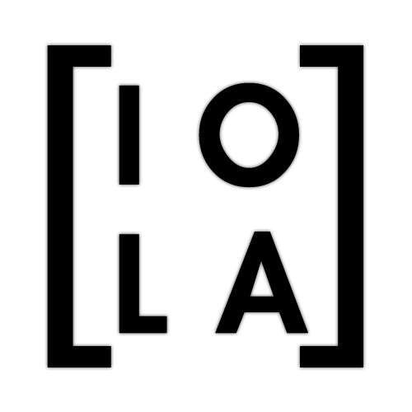
Inquiry-Oriented Linear Algebra (IOLA)

- Topics include: span, linear dependence and independence; systems of linear equations, transformations; eigenvalues, eigenvectors, and change of basis (tasks for determinants and systems also available upon request)
- Materials intended for use in an introductory linear algebra course
- Materials currently available: Student materials (task statements) and instructor support materials (learning goals, examples of student work, implementation notes). For more information (and materials) visit: http://iola.math.vt.edu (login & password required)
- History: Developed under NSF grant numbers 0634074/0634099 (PIs: Zandieh & Rasmussen) and 1245673/1245796/1246083 (Wawro, Zandieh & Rasmussen). Key personnel: Andrews-Larson.
- Evidence of efficacy: data collection scheduled for Fall 2014, analysis ongoing
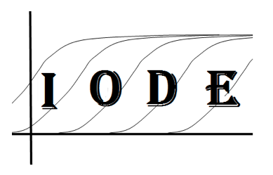
Inquiry-Oriented Differential Equations (IODE)

- Topics include: solving ODEs; numerical, analytic and graphical solution methods; solutions and spaces of solutions; linear systems; linearization; qualitative analysis of both ODEs and linear systems of ODEs; structures of solution spaces, solving second order differential equations
- The materials are meant for a first course in differential equations.
- Materials currently available: Student packet and instructor support materials: iode.wordpress.ncsu.edu
- History: Developed under NSF grant number 9875388 (PI: Rasmussen). Key personnel: Keene.
- For more information, contact kakeene@ncsu.edu or chris.rasmussen@sdsu.edu
- Evidence of efficacy: Kwon, Rasmussen, & Allen, 2005

